





**Course 2 Capstone Peer Review 2 Tutorial**

This tutorial walks you through most of the steps involved in updating the starter code base to implement the MVC pattern. The steps in this tutorial are:

1. (Optional) Clear the app memory (if you have SharingApp installed) **3**

2. Create and implement the Observer Interface **5**

3. Create and implement the Observable class **5**

4. Update the Item class **7**

5. Update the ItemList class **10**

6. Create and implement the ItemController class **12**

7. Create and implement the ItemListController class **14**

8. Update AddItemActivity **16**

9. Update EditItemActivity **18**

10. Update ItemAdapter to use ItemController and ItemController **23**

11. Update ItemsFragment **24**

12. Update AllItemsFragment **26**

13. Update AvailableItemsFragment **27**

14. Update BorrowedItemsFragment **28**

15. Update ContactsActivity **28**

16. Update the Contact class **30**

17. Update the ContactList class to extend the Observable class **31**

18. Create and implement the ContactController class **31**

19. Create and implement the ContactListController class **31**

20. Update the ContactList class **32**

21. Update AddContactActivity **32**

22. Update EditContactActivity **33**

23. Run the app **33**

**You do not necessarily have to go through all these steps manually, you could opt to start this assignment from the Peer Review 2 starter code base.**

**If you are using the Option 1 starter code base, you must still visit steps in the tutorial:**

1. Clear the app memory 4

16. Update the Contact class 33

17. Update the ContactList class to extend the Observable class 33

18. Create and implement the ContactController class 33

19. Create and implement the ContactListController class 33

20. Update the ContactList class 34

21. Update AddContactActivity 35

22. Update EditContactActivity 35

23. Run the app 35

There are hints in these steps, so they are definitely worth checking out!

**Do not run the app before you complete all the required steps!**

When you implement the MVC Pattern for this assignment, the features and functionality of the app should not change. By implementing this design pattern you are simply organizing the code so that there is an observer relationship between the views and the model, and so that there is a barrier between the views and the model, the controllers.

#### 1. (Optional) Clear the app memory (if you have SharingApp installed)

If you already have a previous version of SharingApp on your emulator it is a good idea to clear the app’s data. If we don’t clear the previously stored data then the app may crash due to changes made to the model.

After opening Android Studio click the **play button** to run the app.

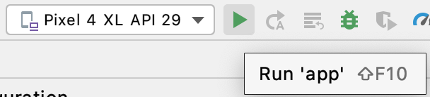

Be patient, the emulator may take a few minutes to load.

If the app launches and doesn’t crash -- great! You are done. Apparently the changes you made to the app did not have an effect on the data being stored. You can now move to **Step 2**.

If it does crash -- don’t worry. A message will appear

to inform you that the app has crashed. Click **OK**.

Then, swipe up and find the Sharing **App. Long click** on the icon to see the **App info**

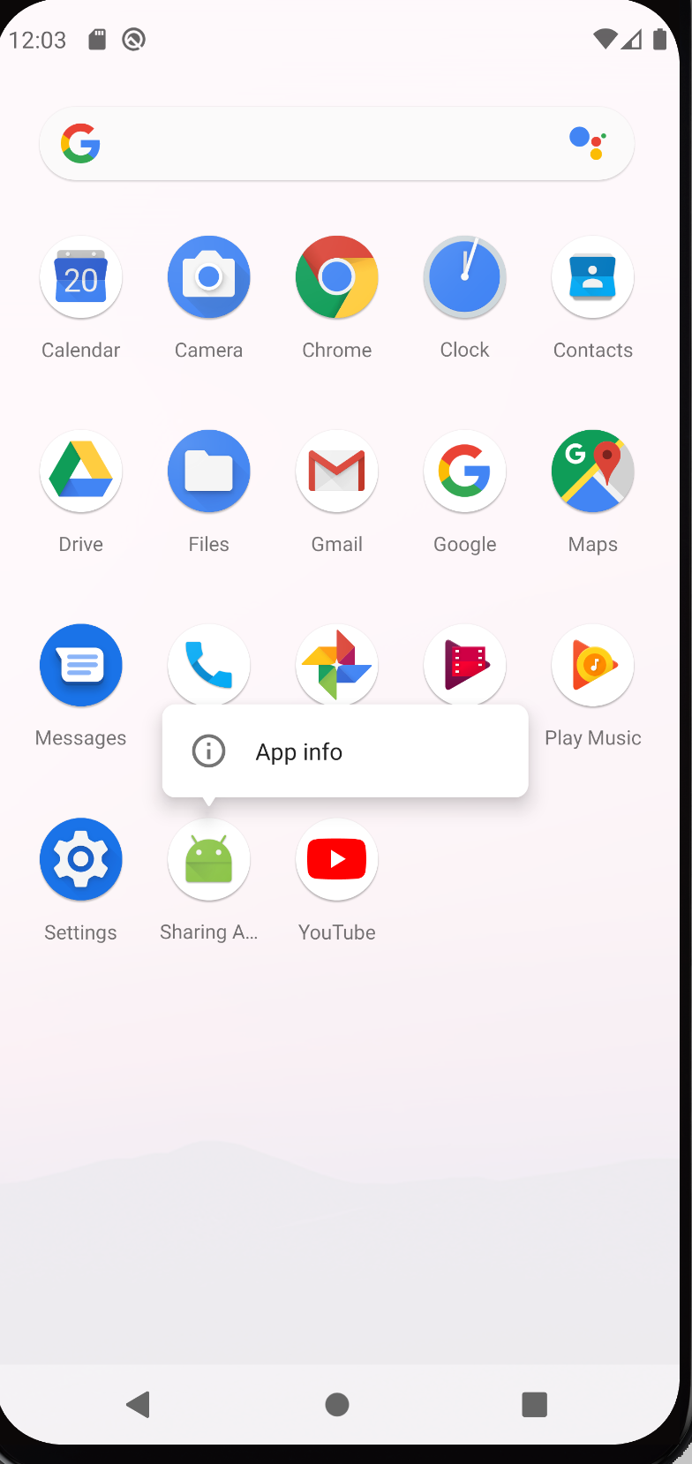

Click **App Info,** and then select **Uninstall**

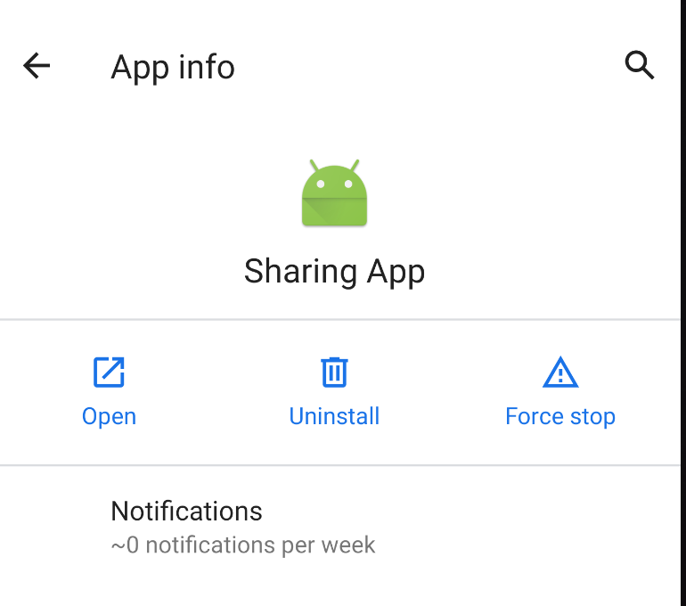

Now the app is uninstalled and all the previously stored data has been erased.

#### 2. Create and implement the Observer Interface

The **Observer** Interface is an essential part of the MVC pattern.

Create a new interface by right-clicking on the **com.example.sharingapp** folder, then click **New** → **Java Class**.

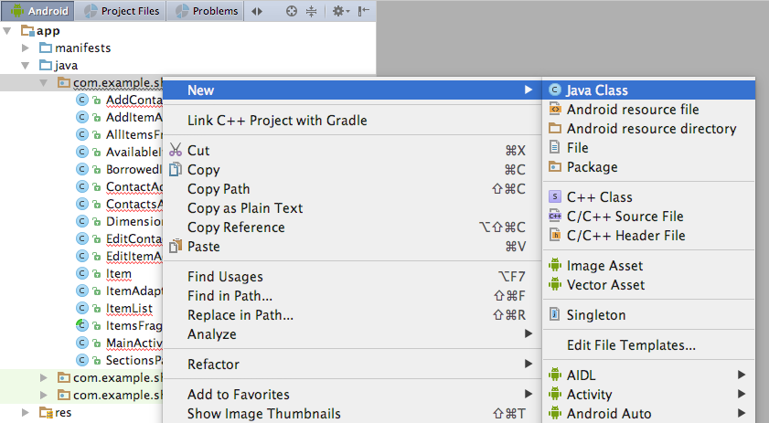

Name it **Observer**. From the dropdown select the option **Interface**, then hit **Enter**.

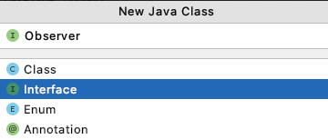

This creates an empty **Observer** interface.

Replace the contents of the **Observer** interface with:

**package** com.example.sharingapp;

*/\*\**

*\* Observer Interface*

*\*/*

**public interface** Observer {

**public void** update();

}

#### 3. Create and implement the Observable class

The **Observable** class is also an essential part of the MVC pattern.

Create a new class by right-clicking on the **com.example.sharingapp** folder, then click **New** → **Java Class**.

Name the class **Observable**. Click **OK**.

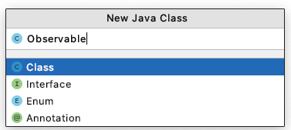

This creates an empty **Observable** class.

Replace the contents of the **Observable** class with:

**package** com.example.sharingapp;

**import** java.util.ArrayList;

*/\*\**

*\* Superclass of Item, ItemList, Contact, ContactList*

*\*/*

**public class** Observable {

**private** ArrayList<Observer> **observers** = **null**;

**public** Observable(){

**observers** = **new** ArrayList<Observer>();

}

*// Notify observers when need to update any changes made to model*

**public void** notifyObservers() {

**for** (Observer observer : **observers**) {

observer.update();

}

}

**public void** addObserver(Observer observer) {

**observers**.add(observer);

}

**public void** removeObserver(Observer observer) {

**if** (**observers**.contains(observer)) {

**observers**.remove(observer);

}

}

}

#### 4. Update the Item class

Double click on the **Item** class to open it.

We need to update the **Item** class so that:

* it inherits from the **Observable** class, and
* all methods that make a change to the model call the **notifyObservers()** method.

Replace the contents of **Item** with:

**package** com.example.sharingapp;

**import** android.graphics.Bitmap;

**import** android.graphics.BitmapFactory;

**import** android.util.Base64;

**import** java.io.ByteArrayOutputStream;

**import** java.util.UUID;

*/\*\**

*\* Item class*

*\*/*

**public class** Item **extends Observable** {

**private** String **title**;

**private** String **maker**;

**private** String **description**;

**private** Dimensions **dimensions**;

**private** String **status**;

**private** Contact **borrower**;

**protected transient** Bitmap **image**;

**protected** String **image_base64**;

**private** String **id**;

**public** Item(String title, String maker, String description, Bitmap image, String id) {

**this**.**title** = title;

**this**.**maker** = maker;

**this**.**description** = description;

**this**.**dimensions** = **null**;

**this**.**status** = **"Available"**;

**this**.**borrower** = **null**;

addImage(image);

**if** (id == **null**){

setId();

} **else** {

updateId(id);

}

}

**public** String getId(){

**return this**.**id**;

}

**public void** setId() {

**this**.**id** = UUID.*randomUUID*().toString();

**notifyObservers();**

}

**public void** updateId(String id){

**this**.**id** = id;

**notifyObservers();**

}

**public void** setTitle(String title) {

**this**.**title** = title;

**notifyObservers();**

}

**public** String getTitle() {

**return title**;

}

**public void** setMaker(String maker) {

**this**.**maker** = maker;

**notifyObservers();**

}

**public** String getMaker() {

**return maker**;

}

**public void** setDescription(String description) {

**this**.**description** = description;

**notifyObservers();**

}

**public** String getDescription() {

**return description**;

}

**public void** setDimensions(String length, String width, String height) {

**this**.**dimensions** = **new** Dimensions(length, width, height);

**notifyObservers();**

}

**public** String getLength(){

**return dimensions**.getLength();

}

**public** String getWidth(){

**return dimensions**.getWidth();

}

**public** String getHeight(){

**return dimensions**.getHeight();

}

**public void** setStatus(String status) {

**this**.**status** = status;

**notifyObservers();**

}

**public** String getStatus() {

**return status**;

}

**public void** setBorrower(Contact borrower) {

**this**.**borrower** = borrower;

**notifyObservers();**

}

**public** Contact getBorrower() {

**return borrower**;

}

**public void** addImage(Bitmap new_image){

**if** (new_image != **null**) {

**image** = new_image;

ByteArrayOutputStream byteArrayBitmapStream = **new** ByteArrayOutputStream();

new_image.compress(Bitmap.CompressFormat.***PNG***, 100, byteArrayBitmapStream);

**byte**[] b = byteArrayBitmapStream.toByteArray();

**image_base64** = Base64.*encodeToString*(b, Base64.***DEFAULT***);

}

**notifyObservers();**

}

**public** Bitmap getImage(){

**if** (**image** == **null** && **image_base64** != **null**) {

**byte**[] decodeString = Base64.*decode*(**image_base64**, Base64.***DEFAULT***);

**image** = BitmapFactory.*decodeByteArray*(decodeString, 0, decodeString.**length**);

**notifyObservers();**

}

**return image**;

}

}

#### 5. Update the ItemList class

Double click on the **ItemList** class to open it.

We need to update the **ItemList** class so that:

* it inherits from the **Observable** class, and
* all methods that make a change to the model call the **notifyObservers()** method.

Replace the contents of **ItemList** with:

**package** com.example.sharingapp;

**import** android.content.Context;

**import** com.google.gson.Gson;

**import** com.google.gson.reflect.TypeToken;

**import** java.io.FileInputStream;

**import** java.io.FileNotFoundException;

**import** java.io.FileOutputStream;

**import** java.io.IOException;

**import** java.io.InputStreamReader;

**import** java.io.OutputStreamWriter;

**import** java.lang.reflect.Type;

**import** java.util.ArrayList;

*/\*\**

*\* ItemList class*

*\*/*

**public class** ItemList **extends** Observable{

**private static** ArrayList<Item> *items*;

**private** String **FILENAME** = **"items.sav"**;

**public** ItemList() {

*items* = **new** ArrayList<Item>();

}

**public void** setItems(ArrayList<Item> item_list) {

*items* = item_list;

**notifyObservers();**

}

**public** ArrayList<Item> getItems() {

**return** *items*;

}

**public void** addItem(Item item) {

*items*.add(item);

**notifyObservers();**

}

**public void** deleteItem(Item item) {

*items*.remove(item);

**notifyObservers();**

}

**public** Item getItem(**int** index) {

**return** *items*.get(index);

}

**public int** getIndex(Item item) {

**int** pos = 0;

**for** (Item i : *items*) {

**if** (item.getId().equals(i.getId())) {

**return** pos;

}

pos = pos + 1;

}

**return** -1;

}

**public int** getSize() {

**return** *items*.size();

}

**public void** loadItems(Context context) {

**try** {

FileInputStream fis = context.openFileInput(**FILENAME**);

InputStreamReader isr = **new** InputStreamReader(fis);

Gson gson = **new** Gson();

Type listType = **new** TypeToken<ArrayList<Item>>() {

}.getType();

*items* = gson.fromJson(isr, listType); *// temporary*

fis.close();

} **catch** (FileNotFoundException e) {

*items* = **new** ArrayList<Item>();

} **catch** (IOException e) {

*items* = **new** ArrayList<Item>();

}

**notifyObservers();**

}

**public boolean** saveItems(Context context) {

**try** {

FileOutputStream fos = context.openFileOutput(**FILENAME**, 0);

OutputStreamWriter osw = **new** OutputStreamWriter(fos);

Gson gson = **new** Gson();

gson.toJson(*items*, osw);

osw.flush();

fos.close();

} **catch** (FileNotFoundException e) {

e.printStackTrace();

**return false**;

} **catch** (IOException e) {

e.printStackTrace();

**return false**;

}

**return true**;

}

**public** ArrayList<Contact> getActiveBorrowers() {

ArrayList<Contact> active_borrowers = **new** ArrayList<Contact>();

**for** (Item i : *items*) {

Contact borrower = i.getBorrower();

**if** (borrower != **null**) {

active_borrowers.add(borrower);

}

}

**return** active_borrowers;

}

**public** ArrayList<Item> filterItemsByStatus(String status){

ArrayList<Item> selected_items = **new** ArrayList<>();

**for** (Item i: *items*) {

**if** (i.getStatus().equals(status)) {

selected_items.add(i);

}

}

**return** selected_items;

}

}

At this point, you have updated the **Item** related model to inherit from the **Observable** class and to make calls to the **notifyObservers()** method when the model is changed. We will have to do this for the **Contact** related model as well, but we will revisit that later in the tutorial.

Next, we will implement the **Item** related controllers. Recall that controllers are used by views (Activities/Fragments) to interact with the model. In MVC views do not make direct contact with the model, instead controllers act as the buffer between them.

#### 6. Create and implement the ItemController class

Create a new class by right-clicking on the **com.example.sharingapp** folder, then click **New** → **Java Class**.

Name the class **ItemController**. Click **OK**. This creates an empty **ItemController** class.

Replace the contents of **ItemController** with:

**package** com.example.sharingapp;

**import** android.graphics.Bitmap;

*/\*\**

*\* ItemController is responsible for all communication between views and Item object*

*\*/*

**public class** ItemController {

**private** Item **item**;

**public** ItemController(Item item){

**this**.**item** = item;

}

**public** String getId(){

**return item**.getId();

}

**public void** setId() {

**item**.setId();

}

**public void** setTitle(String title) {

**item**.setTitle(title);

}

**public** String getTitle() {

**return item**.getTitle();

}

**public void** setMaker(String maker) {

**item**.setMaker(maker);

}

**public** String getMaker() {

**return item**.getMaker();

}

**public void** setDescription(String description) {

**item**.setDescription(description);

}

**public** String getDescription() {

**return item**.getDescription();

}

**public void** setDimensions(String length, String width, String height) {

**item**.setDimensions(length, width, height);

}

**public** String getLength() {

**return item**.getLength();

}

**public** String getWidth(){

**return item**.getWidth();

}

**public** String getHeight(){

**return item**.getHeight();

}

**public void** setStatus(String status) {

**item**.setStatus(status);

}

**public** String getStatus() {

**return item**.getStatus();

}

**public void** setBorrower(Contact borrower) {

**item**.setBorrower(borrower);

}

**public** Contact getBorrower() {

**return item**.getBorrower();

}

**public void** addImage(Bitmap new_image){

**item**.addImage(new_image);

}

**public** Bitmap getImage(){

**return item**.getImage();

}

**public** Item getItem() { **return this**.**item**; }

**public void** addObserver(Observer observer) {

**item**.addObserver(observer);

}

**public void** removeObserver(Observer observer) {

**item**.removeObserver(observer);

}

}

#### 7. Create and implement the ItemListController class

Create a new class by right-clicking on the **com.example.sharingapp** folder, then click **New** → **Java Class**.

Name the class **ItemListController**. Click **OK**. This creates an empty **ItemListController** class.

Replace the contents of **ItemListController** with:

**package** com.example.sharingapp;

**import** android.content.Context;

**import** java.util.ArrayList;

*/\*\**

*\* ItemListController is responsible for all communication between views and ItemList object*

*\*/*

**public class** ItemListController {

**private** ItemList **item_list**;

**public** ItemListController(ItemList item_list){

**this**.**item_list** = item_list;

}

**public void** setItems(ArrayList<Item> item_list) {

**this**.**item_list**.setItems(item_list);

}

**public** ArrayList<Item> getItems() {

**return item_list**.getItems();

}

**public boolean** addItem(Item item, Context context){

AddItemCommand add_item_command = **new** AddItemCommand(**item_list**, item, context);

add_item_command.execute();

**return** add_item_command.isExecuted();

}

**public boolean** deleteItem(Item item, Context context) {

DeleteItemCommand delete_item_command = **new** DeleteItemCommand(**item_list**, item, context);

delete_item_command.execute();

**return** delete_item_command.isExecuted();

}

**public boolean** editItem(Item item, Item updated_item, Context context){

EditItemCommand edit_item_command = **new** EditItemCommand(**item_list**, item, updated_item, context);

edit_item_command.execute();

**return** edit_item_command.isExecuted();

}

**public** Item getItem(**int** index) {

**return item_list**.getItem(index);

}

**public int** getIndex(Item item) {

**return item_list**.getIndex(item);

}

**public int** getSize() {

**return item_list**.getSize();

}

**public void** loadItems(Context context) {

**item_list**.loadItems(context);

}

**public** ArrayList<Contact> getActiveBorrowers() {

**return item_list**.getActiveBorrowers();

}

**public** ArrayList<Item> filterItemsByStatus(String status){

**return item_list**.filterItemsByStatus(status);

}

**public void** addObserver(Observer observer) {

**item_list**.addObserver(observer);

}

**public void** removeObserver(Observer observer) {

**item_list**.removeObserver(observer);

}

}

Now the item related commands are called from the **ItemListController** class. That is, the **addItem()** method uses the **addItemCommand**, the **deleteItem()** method uses the **deleteItemCommand**, and the **editItem()** method uses the **editItemCommand**.

At this point we have made all **Item** related controllers. We will have to make controllers for the **Contact** related model as well, but we will revisit that later in the tutorial.

Next, we will update our views (Activities/Fragments) to make use of **ItemController** and **ItemListController**.

#### 8. Update AddItemActivity

Double click on the **AddItemActivity** class to open it.

We need to:

* Create instances of the **ItemController** and **ItemListController** classes, and
* Replace calls to **Item** with calls to **ItemController**.
* Replace calls to **ItemList**, and **AddItemCommand** with calls to **ItemListController**.

Replace the current contents of **AddItemActivity** with:

**package** com.example.sharingapp;

**import** android.content.Context;

**import** android.content.Intent;

**import** android.graphics.Bitmap;

**import** android.provider.MediaStore;

**import** androidx.appcompat.app.AppCompatActivity;

**import** android.os.Bundle;

**import** android.view.View;

**import** android.widget.EditText;

**import** android.widget.ImageView;

*/\*\**

*\* Add a new item*

*\*/*

**public class** AddItemActivity **extends** AppCompatActivity {

**private** EditText **title**;

**private** EditText **maker**;

**private** EditText **description**;

**private** EditText **length**;

**private** EditText **width**;

**private** EditText **height**;

**private** ImageView **photo**;

**private** Bitmap **image**;

**private int REQUEST_CODE** = 1;

**private** ItemList **item_list** = **new** ItemList();

**private** ItemListController **item_list_controller** = **new** ItemListController(**item_list**);

**private** Context **context**;

@Override

**protected void** onCreate(Bundle savedInstanceState) {

**super**.onCreate(savedInstanceState);

setContentView(R.layout.***activity_add_item***);

**title** = (EditText) findViewById(R.id.***title***);

**maker** = (EditText) findViewById(R.id.***maker***);

**description** = (EditText) findViewById(R.id.***description***);

**length** = (EditText) findViewById(R.id.***length***);

**width** = (EditText) findViewById(R.id.***width***);

**height** = (EditText) findViewById(R.id.***height***);

**photo** = (ImageView) findViewById(R.id.***image_view***);

**photo**.setImageResource(android.R.drawable.***ic_menu_gallery***);

**context** = getApplicationContext();

**item_list_controller**.loadItems(**context**);

}

**public void** saveItem (View view) {

String title_str = **title**.getText().toString();

String maker_str = **maker**.getText().toString();

String description_str = **description**.getText().toString();

String length_str = **length**.getText().toString();

String width_str = **width**.getText().toString();

String height_str = **height**.getText().toString();

**if** (title_str.equals(**""**)) {

**title**.setError(**"Empty field!"**);

**return**;

}

**if** (maker_str.equals(**""**)) {

**maker**.setError(**"Empty field!"**);

**return**;

}

**if** (description_str.equals(**""**)) {

**description**.setError(**"Empty field!"**);

**return**;

}

**if** (length_str.equals(**""**)) {

**length**.setError(**"Empty field!"**);

**return**;

}

**if** (width_str.equals(**""**)) {

**width**.setError(**"Empty field!"**);

**return**;

}

**if** (height_str.equals(**""**)) {

**height**.setError(**"Empty field!"**);

**return**;

}

Item item = **new** Item(title_str, maker_str, description_str, **image**, **null**);

ItemController item_controller = **new** ItemController(item);

item_controller.setDimensions(length_str, width_str, height_str);

*// Add item*

**boolean** success = **item_list_controller**.addItem(item, **context**);

**if** (!success) {

**return**;

}

*// End AddItemActivity*

Intent intent = **new** Intent(**this**, MainActivity.**class**);

startActivity(intent);

}

**public void** addPhoto(View view) {

Intent intent = **new** Intent(MediaStore.***ACTION_IMAGE_CAPTURE***);

**if** (intent.resolveActivity(getPackageManager()) != **null**) {

startActivityForResult(intent, **REQUEST_CODE**);

}

}

**public void** deletePhoto(View view) {

**image** = **null**;

**photo**.setImageResource(android.R.drawable.***ic_menu_gallery***);

}

@Override

**protected void** onActivityResult(**int** request_code, **int** result_code, Intent intent){

**if** (request_code == **REQUEST_CODE** && result_code == ***RESULT_OK***){

Bundle extras = intent.getExtras();

**image** = (Bitmap) extras.get(**"data"**);

**photo**.setImageBitmap(**image**);

}

}

}

#### 9. Update EditItemActivity

Double click on the **EditItemActivity** class to open it.

We need to update **EditItemActivity** to:

* Implement the **Observer** interface
* Create instances of the **ItemController and** **ItemListController** classes, and
* Replace calls to **Item** with calls to **ItemController**.
* Replace calls to **ItemList, EditItemCommand,** and **DeleteItemCommand** with calls to **ItemListController**.

Replace the current contents of **EditItemActivity** with:

**package** com.example.sharingapp;

**import** android.content.Context;

**import** android.content.Intent;

**import** android.graphics.Bitmap;

**import** android.provider.MediaStore;

**import** androidx.appcompat.app.AppCompatActivity;

**import** android.os.Bundle;

**import** android.view.View;

**import** android.widget.ArrayAdapter;

**import** android.widget.EditText;

**import** android.widget.ImageView;

**import** android.widget.Spinner;

**import** android.widget.Switch;

**import** android.widget.TextView;

*/\*\**

*\* Editing a pre-existing item consists of deleting the old item and adding a new item with the old*

*\* item's id.*

*\* Note: invisible EditText is used to setError for status. For whatever reason we cannot .setError to*

*\* the status Switch so instead an error is set to an "invisible" EditText.*

*\*/*

**public class** EditItemActivity **extends** AppCompatActivity **implements** Observer {

**private** ItemList **item_list** = **new** ItemList();

**private** ItemListController **item_list_controller** = **new** ItemListController(**item_list**);

**private** Item **item**;

**private** ItemController **item_controller**;

**private** Context **context**;

**private** ContactList **contact_list** = **new** ContactList();

**private** ContactListController **contact_list_controller** = **new** ContactListController(**contact_list**);

**private** Bitmap **image**;

**private int REQUEST_CODE** = 1;

**private** ImageView **photo**;

**private** EditText **title**;

**private** EditText **maker**;

**private** EditText **description**;

**private** EditText **length**;

**private** EditText **width**;

**private** EditText **height**;

**private** Spinner **borrower_spinner**;

**private** TextView **borrower_tv**;

**private** Switch **status**;

**private** EditText **invisible**;

**private** ArrayAdapter<String> **adapter**;

**private boolean on_create_update** = **false**;

**private int pos**;

@Override

**protected void** onCreate(Bundle savedInstanceState) {

**super**.onCreate(savedInstanceState);

setContentView(R.layout.***activity_edit_item***);

**title** = (EditText) findViewById(R.id.***title***);

**maker** = (EditText) findViewById(R.id.***maker***);

**description** = (EditText) findViewById(R.id.***description***);

**length** = (EditText) findViewById(R.id.***length***);

**width** = (EditText) findViewById(R.id.***width***);

**height** = (EditText) findViewById(R.id.***height***);

**borrower_spinner** = (Spinner) findViewById(R.id.***borrower_spinner***);

**borrower_tv** = (TextView) findViewById(R.id.***borrower_tv***);

**photo** = (ImageView) findViewById(R.id.***image_view***);

**status** = (Switch) findViewById(R.id.***available_switch***);

**invisible** = (EditText) findViewById(R.id.***invisible***);

**invisible**.setVisibility(View.***GONE***);

Intent intent = getIntent(); *// Get intent from ItemsFragment*

**pos** = intent.getIntExtra(**"position"**, 0);

**context** = getApplicationContext();

**item_list_controller**.addObserver(**this**);

**item_list_controller**.loadItems(**context**);

**on_create_update** = **true**;

**contact_list_controller**.addObserver(**this**);

**contact_list_controller**.loadContacts(**context**);

**on_create_update** = **false**;

}

**public void** addPhoto(View view) {

Intent intent = **new** Intent(MediaStore.***ACTION_IMAGE_CAPTURE***);

**if** (intent.resolveActivity(getPackageManager()) != **null**) {

startActivityForResult(intent, **REQUEST_CODE**);

}

}

**public void** deletePhoto(View view) {

**image** = **null**;

**photo**.setImageResource(android.R.drawable.***ic_menu_gallery***);

}

@Override

**protected void** onActivityResult(**int** request_code, **int** result_code, Intent intent){

**if** (request_code == **REQUEST_CODE** && result_code == ***RESULT_OK***){

Bundle extras = intent.getExtras();

**image** = (Bitmap) extras.get(**"data"**);

**photo**.setImageBitmap(**image**);

}

}

**public void** deleteItem(View view) {

*// Delete item*

**boolean** success = **item_list_controller**.deleteItem(**item**, **context**);

**if** (!success) {

**return**;

}

*// End EditItemActivity*

**item_list_controller**.removeObserver(**this**);

Intent intent = **new** Intent(**this**, MainActivity.**class**);

startActivity(intent);

}

**public void** saveItem(View view) {

String title_str = **title**.getText().toString();

String maker_str = **maker**.getText().toString();

String description_str = **description**.getText().toString();

String length_str = **length**.getText().toString();

String width_str = **width**.getText().toString();

String height_str = **height**.getText().toString();

Contact contact = **null**;

**if** (!**status**.isChecked()) {

String borrower_str = **borrower_spinner**.getSelectedItem().toString();

contact = **contact_list_controller**.getContactByUsername(borrower_str);

}

**if** (title_str.equals(**""**)) {

**title**.setError(**"Empty field!"**);

**return**;

}

**if** (maker_str.equals(**""**)) {

**maker**.setError(**"Empty field!"**);

**return**;

}

**if** (description_str.equals(**""**)) {

**description**.setError(**"Empty field!"**);

**return**;

}

**if** (length_str.equals(**""**)) {

**length**.setError(**"Empty field!"**);

**return**;

}

**if** (width_str.equals(**""**)) {

**width**.setError(**"Empty field!"**);

**return**;

}

**if** (height_str.equals(**""**)) {

**height**.setError(**"Empty field!"**);

**return**;

}

String id = **item_controller**.getId(); *// Reuse the item id*

Item updated_item = **new** Item(title_str, maker_str, description_str, **image**, id);

ItemController updated_item_controller = **new** ItemController(updated_item);

updated_item_controller.setDimensions(length_str, width_str, height_str);

**boolean** checked = **status**.isChecked();

**if** (!checked) {

updated_item_controller.setStatus(**"Borrowed"**);

updated_item_controller.setBorrower(contact);

}

*// Edit item*

**boolean** success = **item_list_controller**.editItem(**item**, updated_item, **context**);

**if** (!success) {

**return**;

}

*// End EditItemActivity*

**item_list_controller**.removeObserver(**this**);

Intent intent = **new** Intent(**this**, MainActivity.**class**);

startActivity(intent);

}

*/\*\**

*\* Checked == "Available"*

*\* Unchecked == "Borrowed"*

*\*/*

**public void** toggleSwitch(View view){

**if** (**status**.isChecked()) {

*// Means was previously borrowed, switch was toggled to available*

**borrower_spinner**.setVisibility(View.***GONE***);

**borrower_tv**.setVisibility(View.***GONE***);

**item_controller**.setBorrower(**null**);

**item_controller**.setStatus(**"Available"**);

} **else** {

*// Means not borrowed*

**if** (**contact_list**.getSize()==0){

*// No contacts, need to add contacts to be able to add a borrower*

**invisible**.setEnabled(**false**);

**invisible**.setVisibility(View.***VISIBLE***);

**invisible**.requestFocus();

**invisible**.setError(**"No contacts available! Must add borrower to contacts."**);

**status**.setChecked(**true**); *// Set switch to available*

} **else** {

*// Means was previously available*

**borrower_spinner**.setVisibility(View.***VISIBLE***);

**borrower_tv**.setVisibility(View.***VISIBLE***);

}

}

}

*/\*\**

*\* Only need to update the view from the onCreate method*

*\*/*

**public void** update() {

**if** (**on_create_update**){

**adapter** = **new** ArrayAdapter<String>(**this**, android.R.layout.***simple_spinner_dropdown_item***,

**contact_list_controller**.getAllUsernames());

**borrower_spinner**.setAdapter(**adapter**);

**item** = **item_list_controller**.getItem(**pos**);

**item_controller** = **new** ItemController(**item**);

Contact contact = **item_controller**.getBorrower();

**if** (contact != **null**){

**int** contact_pos = **contact_list_controller**.getIndex(contact);

**borrower_spinner**.setSelection(contact_pos);

}

**title**.setText(**item_controller**.getTitle());

**maker**.setText(**item_controller**.getMaker());

**description**.setText(**item_controller**.getDescription());

**length**.setText(**item_controller**.getLength());

**width**.setText(**item_controller**.getWidth());

**height**.setText(**item_controller**.getHeight());

String status_str = **item_controller**.getStatus();

**if** (status_str.equals(**"Borrowed"**)) {

**status**.setChecked(**false**);

} **else** {

**borrower_tv**.setVisibility(View.***GONE***);

**borrower_spinner**.setVisibility(View.***GONE***);

}

**image** = **item_controller**.getImage();

**if** (**image** != **null**) {

**photo**.setImageBitmap(**image**);

} **else** {

**photo**.setImageResource(android.R.drawable.***ic_menu_gallery***);

}

}

}

}

Notice that everything related to the **ContactListController** is shown in **red**. This makes sense because we have not yet created the **ContactListController** class. For now, this is fine -- just ignore the errors. Later on in the tutorial you will have a chance to create and implement the **ContactListController** class.

#### 10. Update ItemAdapter to use ItemController and ItemController

Double click on the **ItemAdapter** class to open it.

We need to:

* Create an instance of the **ItemController** class, and
* Replace calls to the **Item** class with calls to the **ItemController**

**package** com.example.sharingapp;

**import** android.content.Context;

**import** android.graphics.Bitmap;

**import** androidx.fragment.app.Fragment;

**import** android.view.LayoutInflater;

**import** android.view.View;

**import** android.view.ViewGroup;

**import** android.widget.ArrayAdapter;

**import** android.widget.ImageView;

**import** android.widget.TextView;

**import** java.util.ArrayList;

*/\*\**

*\* ItemAdapter is responsible for what information is displayed in ListView entries.*

*\*/*

**public class** ItemAdapter **extends** ArrayAdapter<Item> {

**private** LayoutInflater **inflater**;

**private** Fragment **fragment**;

**private** Context **context**;

**public** ItemAdapter(Context context, ArrayList<Item> items, Fragment fragment) {

**super**(context, 0, items);

**this**.**context** = context;

**this**.**inflater** = LayoutInflater.*from*(context);

**this**.**fragment** = fragment;

}

@Override

**public** View getView(**int** position, View convertView, ViewGroup parent) {

*// getItem(position) gets the "item" at "position" in the "items" ArrayList*

*// (where "items" is a parameter in the ItemAdapter creator as seen above ^^)*

Item item = getItem(position);

ItemController item_controller = **new** ItemController(item);

String title = **"Title: "** + item_controller.getTitle();

String description = **"Description: "** + item_controller.getDescription();

Bitmap thumbnail = item_controller.getImage();

String status = **"Status: "** + item_controller.getStatus();

*// Check if an existing view is being reused, otherwise inflate the view.*

**if** (convertView == **null**) {

convertView = **inflater**.*from*(**context**).inflate(R.layout.***itemlist_item***, parent, **false**);

}

TextView title_tv = (TextView) convertView.findViewById(R.id.***title_tv***);

TextView status_tv = (TextView) convertView.findViewById(R.id.***status_tv***);

TextView description_tv = (TextView) convertView.findViewById(R.id.***description_tv***);

ImageView photo = (ImageView) convertView.findViewById(R.id.***image_view***);

**if** (thumbnail != **null**) {

photo.setImageBitmap(thumbnail);

} **else** {

photo.setImageResource(android.R.drawable.***ic_menu_gallery***);

}

title_tv.setText(title);

description_tv.setText(description);

*// AllItemFragments: itemlist item shows title, description and status*

**if** (**fragment instanceof** AllItemsFragment ) {

status_tv.setText(status);

}

*// BorrowedItemsFragment/AvailableItemsFragment: itemlist item shows title and description only*

**if** (**fragment instanceof** BorrowedItemsFragment || **fragment instanceof** AvailableItemsFragment) {

status_tv.setVisibility(View.***GONE***);

}

**return** convertView;

}

}

#### 11. Update ItemsFragment

Double click on the **ItemsFragment** class to open it.

We need to update **ItemsFragment** to:

* Implement the **update()** method from the **Observer** interface
* Create an instance of the **ItemListController** class, and
* Replace calls to the **ItemList** class with calls to the **ItemListController**

Replace the current contents of **ItemsFragment** with:

**package** com.example.sharingapp;

**import** android.content.Context;

**import** android.content.Intent;

**import** android.os.Bundle;

**import** androidx.fragment.app.Fragment;

**import** android.view.LayoutInflater;

**import** android.view.View;

**import** android.view.ViewGroup;

**import** android.widget.AdapterView;

**import** android.widget.ArrayAdapter;

**import** android.widget.ListView;

**import** java.util.ArrayList;

*/\*\**

*\* Superclass of AvailableItemsFragment, BorrowedItemsFragment and AllItemsFragment*

*\*/*

**public abstract class** ItemsFragment **extends** Fragment **implements** Observer {

**private** ItemList **item_list** = **new** ItemList();

ItemListController **item_list_controller** = **new** ItemListController(**item_list**);

View **rootView**;

**private** ListView **list_view**;

**private** ArrayAdapter<Item> **adapter**;

**private** ArrayList<Item> **selected_items**;

**private** LayoutInflater **inflater**;

**private** ViewGroup **container**;

**private** Context **context**;

**private** Fragment **fragment**;

**private boolean update** = **false**;

@Override

**public** View onCreateView(LayoutInflater inflater, ViewGroup container, Bundle savedInstanceState) {

**context** = getContext();

*// Don't update view yet. Wait until after items have been filtered.*

**item_list_controller**.loadItems(**context**);

**update** = **true**;

**this**.**inflater** = inflater;

**this**.**container** = container;

**return rootView**;

}

**public void** setVariables(**int** resource, **int** id ) {

**rootView** = **inflater**.inflate(resource, **container**, **false**);

**list_view** = (ListView) **rootView**.findViewById(id);

**selected_items** = filterItems();

}

**public void** loadItems(Fragment fragment){

**this**.**fragment** = fragment;

**item_list_controller**.addObserver(**this**);

**item_list_controller**.loadItems(**context**);

}

**public void** setFragmentOnItemLongClickListener(){

*// When item is long clicked, this starts EditItemActivity*

**list_view**.setOnItemLongClickListener(**new** android.widget.AdapterView.OnItemLongClickListener() {

@Override

**public boolean** onItemLongClick(AdapterView<?> parent, View view, **int** pos, **long** id) {

Item item = **adapter**.getItem(pos);

**int** meta_pos = **item_list_controller**.getIndex(item);

**if** (meta_pos >= 0) {

Intent edit = **new** Intent(**context**, EditItemActivity.**class**);

edit.putExtra(**"position"**, meta_pos);

startActivity(edit);

}

**return true**;

}

});

}

*/\*\**

*\* filterItems is implemented independently by AvailableItemsFragment, BorrowedItemsFragment and AllItemsFragment*

*\** ***@return*** *selected_items*

*\*/*

**public abstract** ArrayList<Item> filterItems();

*/\*\**

*\* Called when the activity is destroyed, thus we remove this fragment as an observer*

*\*/*

@Override

**public void** onDestroy() {

**super**.onDestroy();

**item_list_controller**.removeObserver(**this**);

}

*/\*\**

*\* Update the view*

*\*/*

**public void** update(){

**if** (**update**) {

**adapter** = **new** ItemAdapter(**context**, **selected_items**, **fragment**);

**list_view**.setAdapter(**adapter**);

**adapter**.notifyDataSetChanged();

}

}

}

#### 12. Update AllItemsFragment

Double click on **AllItemsFragment** to open it.

We need to:

* Replace the call to the **ItemList** class with a call to the **ItemListController**.instance instead.
* Make some small changes to the **OnCreateView()** method due to the addition of the **update()** method in **ItemsFragment**

Replace the contents of **AllItemsFragment** with:

**package** com.example.sharingapp;

**import** android.os.Bundle;

**import** android.view.LayoutInflater;

**import** android.view.View;

**import** android.view.ViewGroup;

**import** java.util.ArrayList;

*/\*\**

*\* Displays a list of all items*

*\*/*

**public class** AllItemsFragment **extends** ItemsFragment {

@Override

**public** View onCreateView(LayoutInflater inflater, ViewGroup container, Bundle savedInstanceState) {

**super**.onCreateView(inflater, container, savedInstanceState);

**super**.setVariables(R.layout.***all_items_fragment***, R.id.***my_items***);

**super**.loadItems(AllItemsFragment.**this**);

**super**.setFragmentOnItemLongClickListener();

**return rootView**;

}

**public** ArrayList<Item> filterItems() {

**return item_list_controller**.getItems();

}

}

#### 13. Update AvailableItemsFragment

Double click on **AvailableItemsFragment** to open it.

We need to:

* Replace the call to the **ItemList** class with a call to the **ItemListController**.instance instead.
* Make some small changes to the **OnCreateView()** method due to the addition of the **update()** method in **ItemsFragment**

Replace the contents of **AvailableItemsFragment** with:

**package** com.example.sharingapp;

**import** android.os.Bundle;

**import** android.view.LayoutInflater;

**import** android.view.View;

**import** android.view.ViewGroup;

**import** java.util.ArrayList;

*/\*\**

*\* Displays a list of all "Available" items*

*\*/*

**public class** AvailableItemsFragment **extends** ItemsFragment{

@Override

**public** View onCreateView(LayoutInflater inflater, ViewGroup container, Bundle savedInstanceState) {

**super**.onCreateView(inflater,container, savedInstanceState);

**super**.setVariables(R.layout.***available_items_fragment***, R.id.***my_available_items***);

**super**.loadItems(AvailableItemsFragment.**this**);

**super**.setFragmentOnItemLongClickListener();

**return rootView**;

}

**public** ArrayList<Item> filterItems() {

String status = **"Available"**;

**return item_list_controller**.filterItemsByStatus(status);

}

}

#### 14. Update BorrowedItemsFragment

Double click on **BorrowedtemsFragment** to open it.

We need to:

* Replace the call to the **ItemList** class with a call to the **ItemListController**.instance instead.
* Make some small changes to the **OnCreateView()** method due to the addition of the **update()** method in **ItemsFragment**

Replace the contents of **BorrowedtemsFragment** with:

**package** com.example.sharingapp;

**import** android.os.Bundle;

**import** android.view.LayoutInflater;

**import** android.view.View;

**import** android.view.ViewGroup;

**import** java.util.ArrayList;

*/\*\**

*\* Displays a list of all "Borrowed" Items*

*\*/*

**public class** BorrowedItemsFragment **extends** ItemsFragment {

@Override

**public** View onCreateView(LayoutInflater inflater, ViewGroup container, Bundle savedInstanceState) {

**super**.onCreateView(inflater,container, savedInstanceState);

**super**.setVariables(R.layout.***borrowed_items_fragment***, R.id.***my_borrowed_items***);

**super**.loadItems(BorrowedItemsFragment.**this**);

**super**.setFragmentOnItemLongClickListener();

**return rootView**;

}

**public** ArrayList<Item> filterItems() {

String status = **"Borrowed"**;

**return item_list_controller**.filterItemsByStatus(status);

}

}

#### 15. Update ContactsActivity

Double click on **ContactsActivity** to open it.

We need to:

* Create an instance of the **ItemListController** class, and
* Replace the call to the **ItemList** class with a call to the **ItemListController**

Replace the contents of **ContactsActivity** with:

**package** com.example.sharingapp;

**import** android.content.Context;

**import** android.content.Intent;

**import** android.os.Bundle;

**import** androidx.appcompat.app.AppCompatActivity;

**import** android.view.View;

**import** android.widget.AdapterView;

**import** android.widget.ArrayAdapter;

**import** android.widget.ListView;

**import** android.widget.Toast;

*/\*\**

*\* Displays a list of all contacts*

*\* Note: You will not be able edit/delete contacts which are "active" borrowers*

*\*/*

**public class** ContactsActivity **extends** AppCompatActivity **implements** Observer {

**private** ContactList **contact_list** = **new** ContactList();

**private** ContactListController **contact_list_controller** = **new** ContactListController(**contact_list**);

**private** ContactList **active_borrowers_list** = **new** ContactList();

**private** ContactListController **active_borrowers_list_controller** = **new** ContactListController(**active_borrowers_list**);

**private** ItemList **item_list** = **new** ItemList();

**private** ItemListController **item_list_controller** = **new** ItemListController(**item_list**);

**private** ListView **my_contacts**;

**private** ArrayAdapter<Contact> **adapter**;

**private** Context **context**;

**protected void** onCreate(Bundle savedInstanceState) {

**super**.onCreate(savedInstanceState);

setContentView(R.layout.***activity_contacts***);

**context** = getApplicationContext();

**contact_list_controller**.addObserver(**this**);

**contact_list_controller**.loadContacts(**context**);

**item_list_controller**.loadItems(**context**);

*// When contact is long clicked, this starts EditContactActivity*

**my_contacts**.setOnItemLongClickListener(**new** android.widget.AdapterView.OnItemLongClickListener() {

@Override

**public boolean** onItemLongClick(AdapterView<?> parent, View view, **int** pos, **long** id) {

Contact contact = **adapter**.getItem(pos);

*// Do not allow an "active" borrower to be edited*

**active_borrowers_list_controller**.setContacts(**item_list_controller**.getActiveBorrowers());

**if** (**active_borrowers_list_controller** != **null**) {

**if** (**active_borrowers_list_controller**.hasContact(contact)) {

CharSequence text = **"Cannot edit or delete active borrower!"**;

**int** duration = Toast.***LENGTH_SHORT***;

Toast.*makeText*(**context**, text, duration).show();

**return true**;

}

}

**contact_list_controller**.loadContacts(**context**); *// must load contacts again here*

**int** meta_pos = **contact_list_controller**.getIndex(contact);

Intent intent = **new** Intent(**context**, EditContactActivity.**class**);

intent.putExtra(**"position"**, meta_pos);

startActivity(intent);

**return true**;

}

});

}

@Override

**protected void** onStart() {

**super**.onStart();

**context** = getApplicationContext();

**contact_list_controller**.loadContacts(**context**);

}

**public void** addContactActivity(View view){

Intent intent = **new** Intent(**this**, AddContactActivity.**class**);

startActivity(intent);

}

*/\*\**

*\* Called when the activity is destroyed, thus we remove this activity as a listener*

*\*/*

@Override

**protected void** onDestroy() {

**super**.onDestroy();

**contact_list_controller**.removeObserver(**this**);

}

*/\*\**

*\* Update the view*

*\*/*

**public void** update(){

**my_contacts** = (ListView) findViewById(R.id.***my_contacts***);

**adapter** = **new** ContactAdapter(ContactsActivity.**this**, **contact_list_controller**.getContacts());

**my_contacts**.setAdapter(**adapter**);

**adapter**.notifyDataSetChanged();

}

}

Notice that everything related to **ContactController** and **ContactListController** are shown in **red**. Ignore this for now.

#### 16. Update the Contact class

Double click on the **Contact** class to open it.

Update **Contact** so that:

* It inherits from the **Observable** class, and
* All methods that make a change to the model call the **notifyObservers()** method.

**Hint**: this step is analogous to **Step 4**.

#### 17. Update the ContactList class to extend the Observable class

Double click on the **ContactList** class to open it.

Update **ContactList** so that:

* It inherits from the **Observable** class, and
* All methods that make a change to the model call the **notifyObservers()** method.

**Hint**: this step is analogous to **Step 5**.

#### 18. Create and implement the ContactController class

Create a new class by right-clicking on the **com.example.sharingapp** folder, then click **New** → **Java Class**.

Name the class **ContactController**. Click **OK**. This creates an empty **ContactController** class.

Now it’s your turn to implement it.

**Hint**: this step is analogous to **Step 6**.

#### 19. Create and implement the ContactListController class

Create a new class by right-clicking on the **com.example.sharingapp** folder, then click **New** → **Java Class**.

Name the class **ContactListController**. Click **OK**. This creates an empty **ContactListController** class.

Now it’s your turn to implement it.

**Hint**: this step is analogous to **Step 7**.

Remember that contact related commands should be called from the **ContactListController** class. Don’t forget to implement the following methods in **ContactListController**:

* **addContact()** uses the **AddContactCommand**,
* **deleteContact()** uses the **DeleteContactCommand**, and
* **editContact()** uses the **EditContactCommand**.

Additionally, add the following method to the **ContactListController**

**public** Contact getContactByUsername(String username) {

**return contact_list**.getContactByUsername(username);

}

You’ll notice that we get an error when we call the **getContactByUsername()** method of the **ContactList** class because the method doesn’t exist. We’ll add that in a moment.



#### 20. Update the ContactList class

Double-click on the **ContactList** class.

Add the following method to the **ContactList** class:

**public** Contact getContactByUsername(String username){

**for** (Contact c : *contacts*){

**if** (c.getUsername().equals(username)){

**return** c;

}

}

**return null**;

}

#### 21. Update AddContactActivity

Double click on the **AddContactActivity** class to open it.

Update **AddContactActivity** to:

* Create an instance of the **ContactListController** class, and
* Replace calls to **ContactList** and **AddContactCommand** with calls to the **ContactListController**.

**Hint**: this step is analogous to **Step 8**.

#### 22. Update EditContactActivity

Double click on the **EditContactActivity** class to open it.

We need to update **EditContactActivity** to:

* Implement the **Observer** interface
* Create instances of the **ContactController and** **ContactListController** classes,
* Replace calls to **Contact** with calls to **ContactController**.
* Replace calls to **ContactList, EditContactCommand,** and **DeleteContactCommand** with calls to **ContactListController**.

**Hint**: this step is analogous to **Step 9**.

#### 23. Run the app

Assuming you have correctly implemented the MVC Design Pattern then at this point you should be able to run the app by clicking the **play** button.



Be patient! It may take a few minutes to open and launch SharingApp.